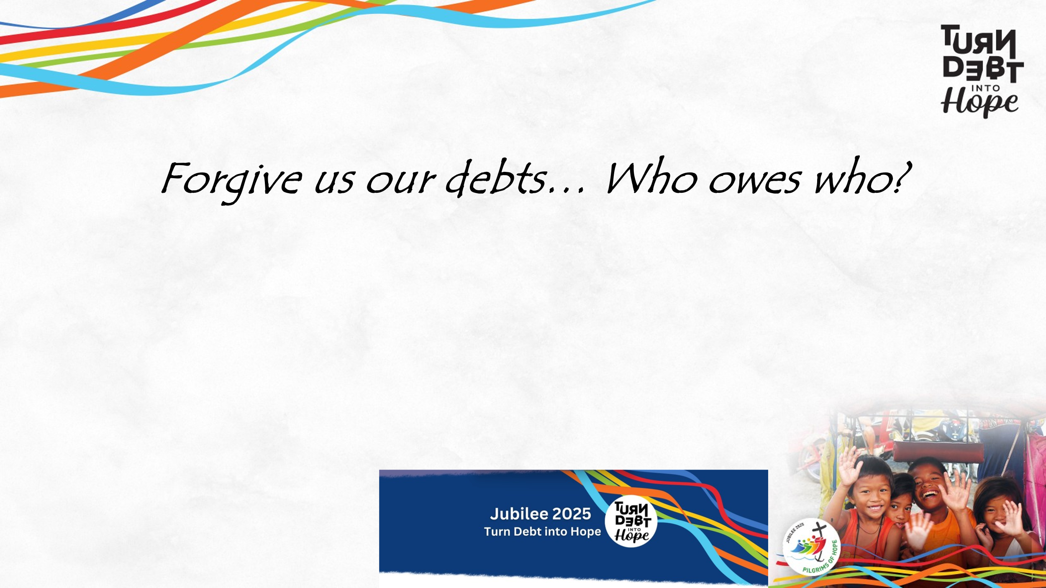
Sermon - April 27, 2025 TUMC – Randy Haluza-DeLay (1970 words)
“Forgive us our debts… Who owes who?” slide here.
1.
Today we celebrate Earth day. 2025 is also proclaimed as a "year of jubilee." Jubilee, simply is liberation. So let's talk about jubilee and environment together. In a secular terminology, we would say “environmental justice.” In a Christian worldview we would say “listen to the cry of the earth and the cry of the poor.”
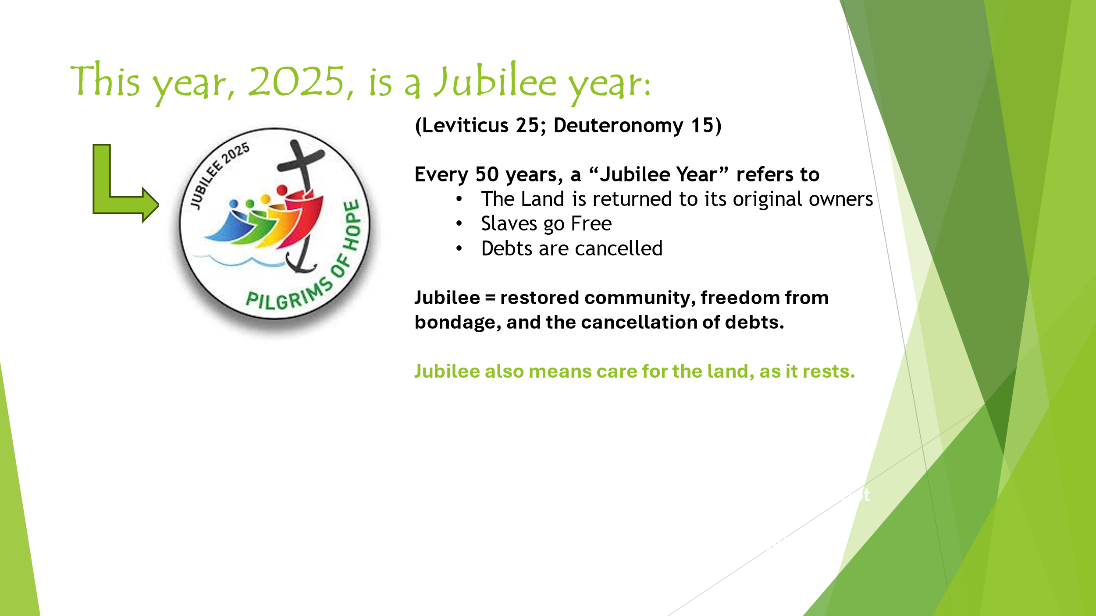
Those passages that were read from Leviticus and Deuteronomy indicate what this means. Every 7th year was a sabbatical year, and every 50th year was a year of jubilee. It is this Jubilee notion that Jesus referred to when he announced his ministry in Luke 4, and quoting Isaiah, said that he had come proclaim good news, freedom, healing and “to set the oppressed free, and proclaim the acceptable year of the lord."
As we heard Carolyn read, this is what happens in the Year of Jubilee, slide here.
A “Jubilee Year” was supposed to mean:
- The Land is returned to its original owners.
- Slaves go Free
- Debts are cancelled
That first one is significant, because it prevents the accumulation of wealth over time. For the Israelites, as for most of human history, Wealth was in land, not stored in money as it is for us, so if land/wealth had to be returned every 50 years, wealth couldn’t accumulate.
Overall , Jubilee intends restored community, freedom from bondage, and the elimination of burdens (debts). Jubilee also meant care for the land, allowing the land itself to rests.
Debt forgiveness and mechanisms for restoring relations in a community that would otherwise be sundered by these financial burdens have a long history in the Hebrew Bible and the New Testament, including scripture that we read today, and the full chapter (Lev 25).
Historically there's solid evidence that Jubilee forms of debt cancellation were practiced in the Middle East among the neighbors of Israel of that time. There’s obviously not time to give details of the history as scholars know it, but the point is that while it was certainly not practiced every 50 years in accord with Mosaic law, this was not a pie-in-the-sky idealization. Jubilee has the seeds of a practical means of providing mechanisms toward a more fair and just society. And as the parable in Matthew indicates, beware of not following through!

For many Christian churches and organizations the goal of this Year of Jubilee 2025 is to “Turn Debt into Hope.” It’s a worldwide campaign calling for the cancellation of the financial debts of countries for whom financial debt creates an unjust burden on it and their citizens. We ask you to sign the petitions that are in the lobby if you are willing. I’ll explain more in a bit.
But there's another aspect of Who Owes Who that's worth focusing on here at Earth Day. That is ecological debt- a debt primarily owed by the wealthy countries of the Global North to the countries of the Global South. In other words, although we rightfully talk about a financial debt crisis, but – Who REALLY Owes WHO?
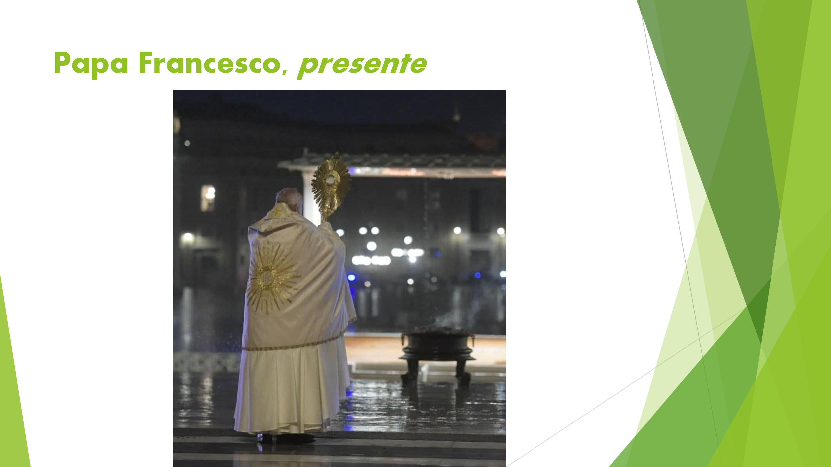
Ecological debt was going to be the focus of this reflection today but We all know that on Monday Pope Francis passed away. slide here. For this Earth Day message let me ALSO unpack a little of the ecological theology of Pope Francis.
A few years ago I gave a series of lectures for Mennonite Church Alberta, called “Faith in the Anthropocene.” Among the comments received afterwards was "We learned that Mennonites should pay attention to Pope Francis." I did not title this reflection that way, but HERE WE GO!

2. Francis…
May 24th is the 10th anniversary of the 2015 release of a document Francis wrote called "Laudato Si’: On care for our common home.” Laudato Si’ means “Praise be,” wording that coming directly from SAINT Francis, you know, the one from Assisi. It is an “encyclical”, the highest-level teaching document in the Catholic church.
If you are interested in a Christian perspective on the environment, you MUST read it. Unlike most encyclicals, it is highly readable. Plus, in my professional opinion, Laudato Si’ is the MOST important Christian document on the environment so far produced. It can be easily found as a free download on the internet.

Laudato Si’ has more elements than I will describe here. It includes a full-blown description of the ecological crisis, and analysis of biblical understandings, and unpacks some of the root causes of ecological degradation. And it emphasizes the effects of environmental degradation on the world's poor.
The most quoted bit in Laudato Si’ is when Francis says "we must listen to the cry of the earth and the cry of the poor" (para 61), a resounding declaration of ecological justice.
Papa Francesco declares, “All this shows the urgent need for us to move forward in a bold cultural revolution.” (Para #114).
“A strategy for real change calls for rethinking processes in their entirety, [he says] for it is not enough to include a few superficial ecological considerations while failing to question the logic which underlies present-day culture.”(para 197).
This requires “an ecological conversion” he concludes.

In 2023, Francis described more of what he meant in another, much shorter statement known as Laudate deum (or “Praise God”). It demands nations get their act together and address the climate crisis. It ALSO tries to clarify “ecological conversion”, the human place in nature, as one that should be characterized by humility and solidarity with other creatures.
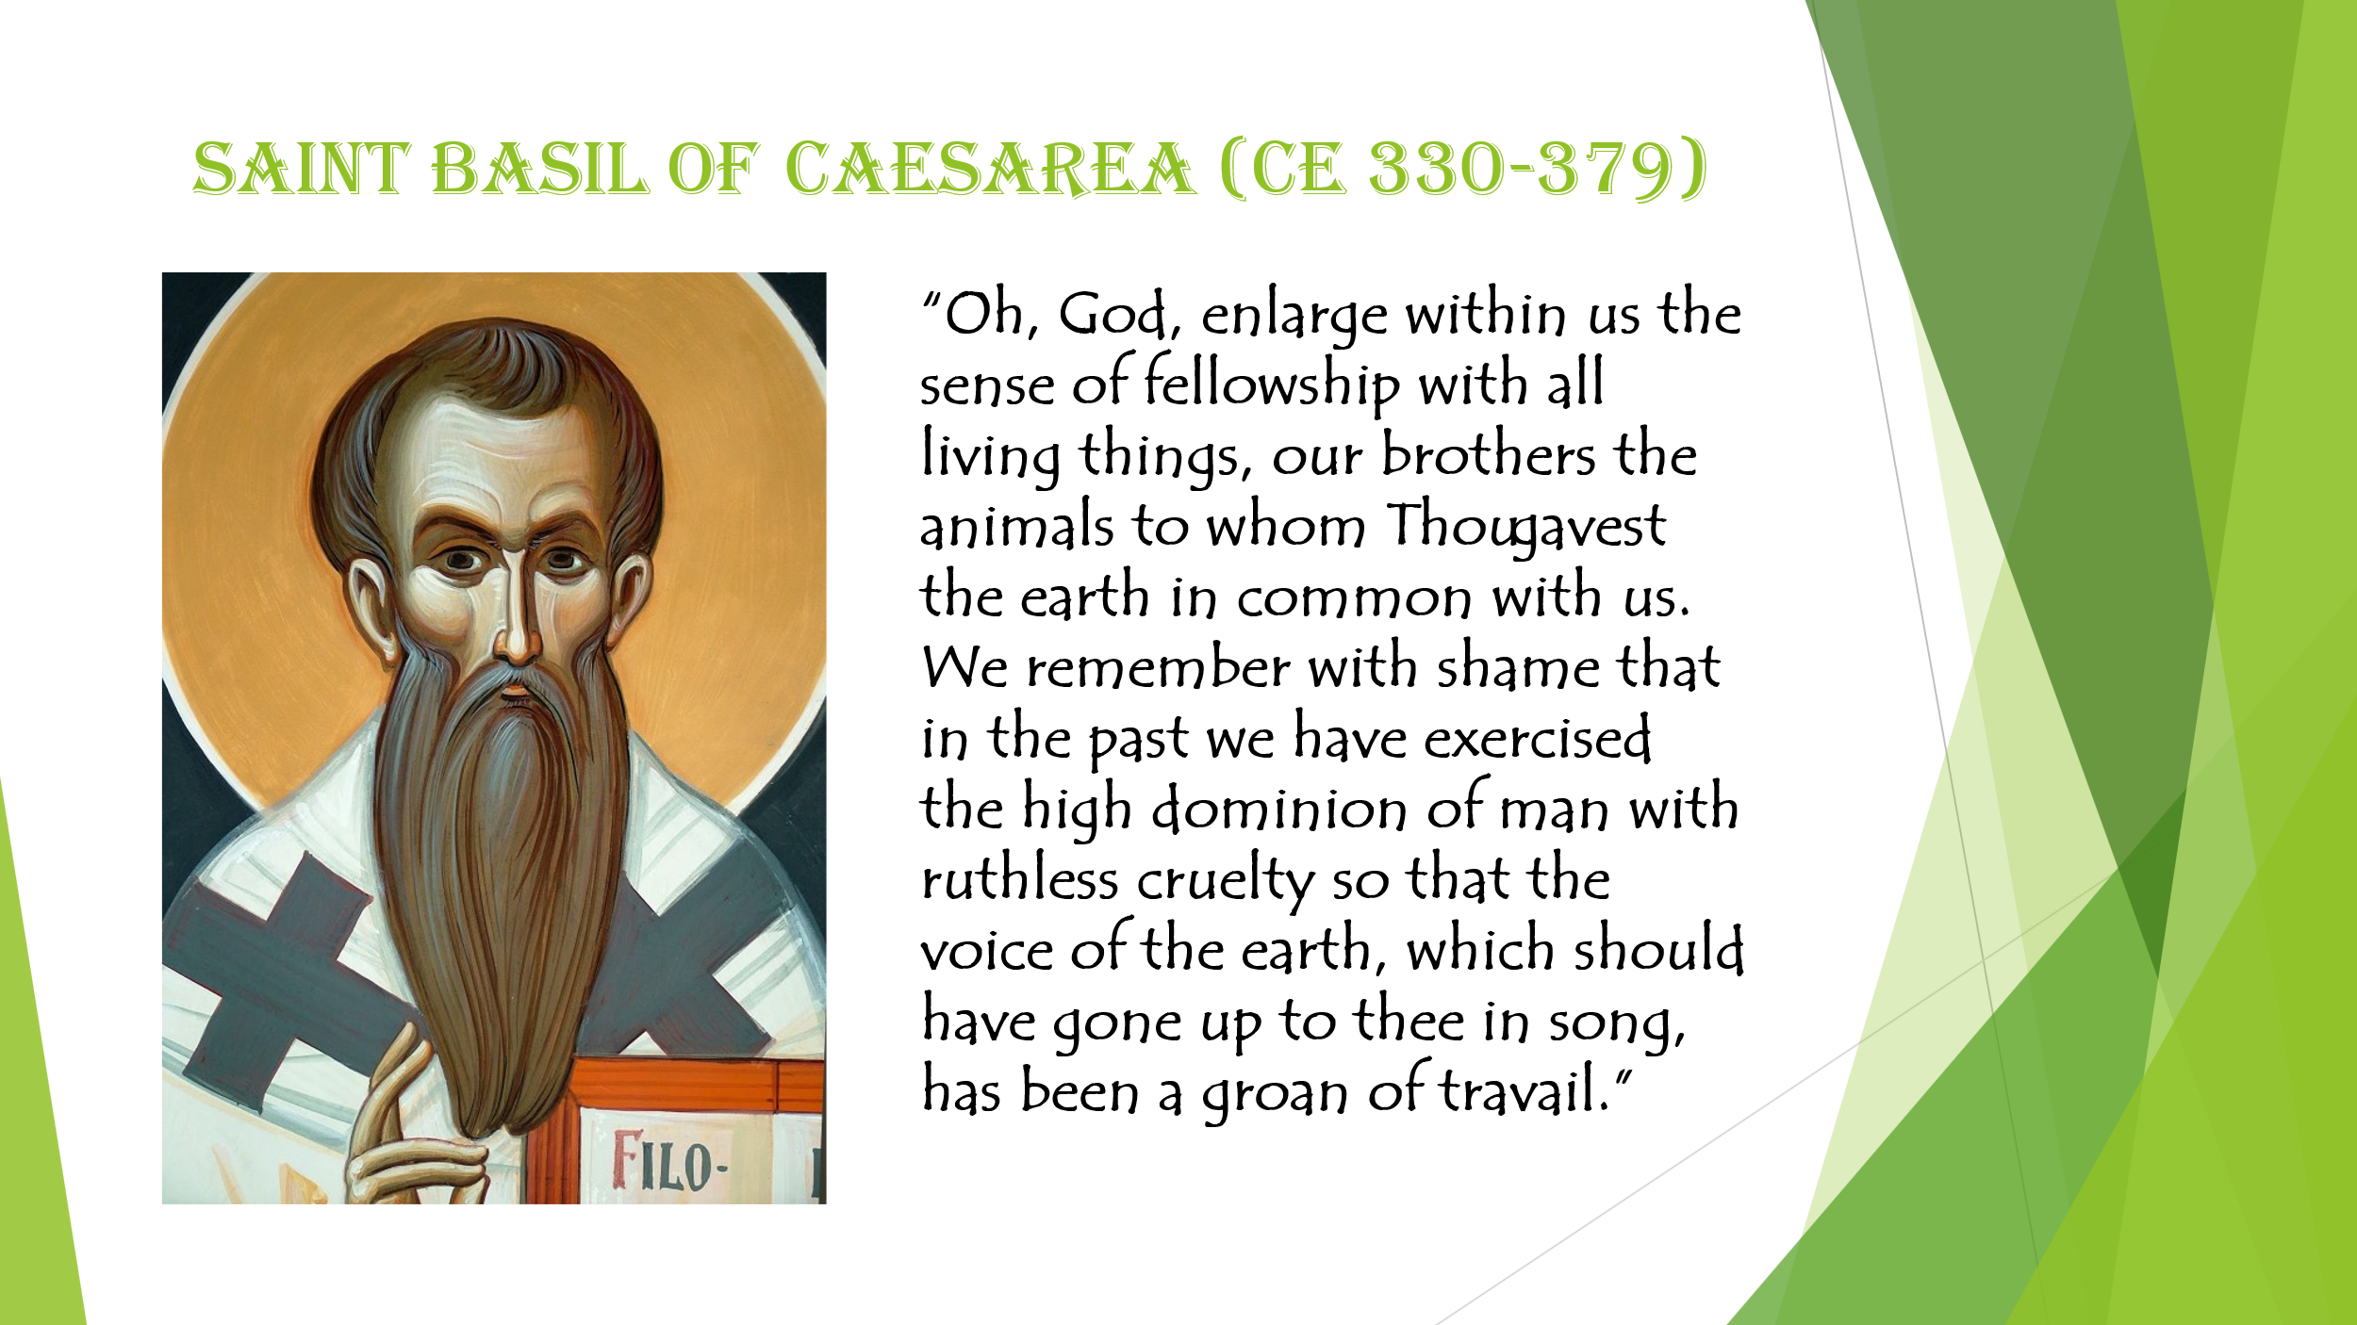
This attitude has often been minimized in Western culture, including the church, but does have a long history within the Christian tradition:
slide here. For example, Saint Basil of Caesarea from the 4th century is quoted thus:
“Oh, God, enlarge within us the sense of fellowship with all living things, our brothers the animals to whom Thou gavest the earth in common with us…. We remember with shame that in the past we have exercised the high dominion of humankind with ruthless cruelty so that the voice of the earth, which should have gone up to thee in song, has been a groan of travail.”
Humility and solidarity with the rest of creation. Amen.

3. JUBILEE & Ecological Debt
Now, I want to return to Jubilee and Turn Debt into Hope. Remember what the scripture reading from Matthew emphasizes – forgiveness is the fundamental Christian practice.
We are all sinners,
to be forgiven,
Praise be, Praise God (Laudate Si’, Laudate Deum)
About a quarter of the countries of the world are facing a financial debt crisis, which places tremendous burdens on the ability of governments to provide for citizens and economic development to raise standards of living. A simple statistic shows this – 3.3 billion of our brothers and sisters live in countries where more money is spent on interest payments than on education or health care. This situation is contrary to Creator’s intent for the lives of all to fully flourish.
In the declaration of 2025 as a Year of Jubilee, Francis wrote:
Echoing the age-old message of the prophets, the Jubilee reminds us that the goods of the earth are not destined for a privileged few, but for everyone….
Another heartfelt appeal that I would make… is directed to the more affluent nations. I ask that they acknowledge the gravity of so many of their past decisions and determine to forgive the debts of countries that will never be able to repay them.
You may remember the Jubilee 2000 debt campaign 25 years ago. It achieved over a 100 billion dollars of debt being forgiven or canceled around the world. But many countries find themselves in crisis again. So this Jubilee campaign petitions TO FIX IT!
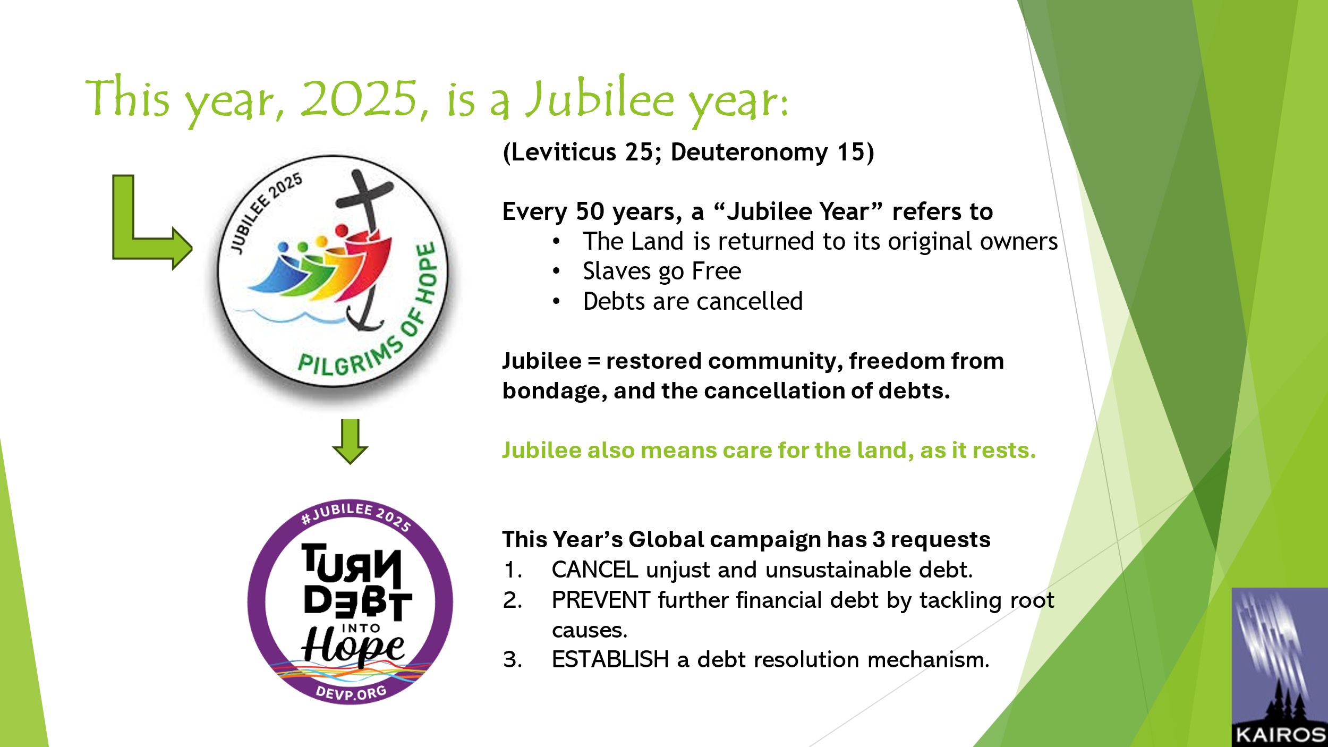
Turn Debt into Hope is a global campaign. It is actively promoted by the World Council of Churches, Catholic agencies at the Vatican, the Eastern Orthodox churches led by Ecumenical Patriarch Bartholemew, and international aid and development agencies and civil society organizations around the world. In Canada the campaign is led by KAIROS (of which MCC is a member organization).
Turn Debt into Hope slide here, has three requests to be presented to World Leaders:
- CANCEL unjust and unsustainable debt.
- PREVENT further financial debt by tackling root causes.
- ESTABLISH a debt resolution mechanism.
If you want more details of any of these, talk to me or Shannon or look into it yourself – we can give you links to position papers that detail some proposals.
The goal is 10 million signatures globally, and 60,000 from Canada over the year, with as many as possible by early June. That’s because, if leaders will listen to the people of the world, we will deliver these signatures to the meeting of the heads of the 7 largest economies in the world – the G7 – who will be meeting in Alberta in June, and then to G20, United Nations, and other gatherings of world leaders.
And by the way, we are also organizing a 3-day Jubilee People’s Forum to take place right before the G7 in Calgary with learning and activism to raise our voices of faith(June 12-15). https://www.kairoscanada.org/jubilee-2025-canada/g7-peoples-forum

But there is a deeper question, that of WHO REALLY OWES WHO?
Cancellation of financial debt can seem like a wonderful charitable action of goodwill, leaving us Global Northerners to believe that we are good people because we propose to forgive the debt and forgo the money from those in the global south.
However, the simple fact is that much of the wealth of the global North is due to, or was seeded by, the extraction of resources from the global South.
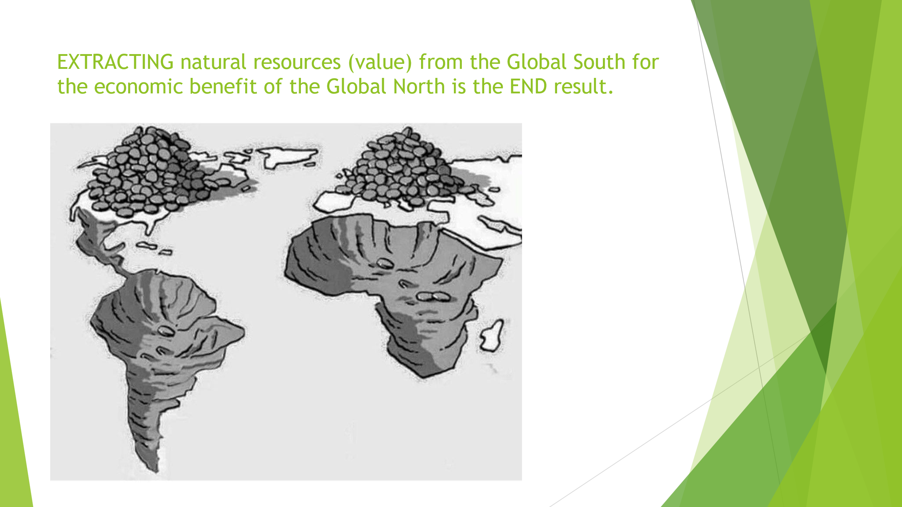
It looks this way- -(pic of extractivism) slide here
The continents of Africa and South America have been mined, and the Global North is piled with money. That is a depiction of the World Economic System, as a function of the recent 500 years of colonialism. That’s one part of ecological debt.
Back in 2009 the Ecuadorean organization (and KAIROS partner) Acción Ecológica defined ecological debt as
“the debt accumulated by northern industrial countries towards third world countries [sic] on account of resource plundering and use of environmental space to deposit wastes.”
Francis himself referred to “ecological debt” in Laudato Si’, saying the situation is
made all the more serious today by a new form of injustice which we increasingly recognize, namely, that “a true ‘ecological debt’ exists,
particularly between the global North and South, connected to economic imbalances with effects on the environment and the disproportionate use of natural resources by certain countries over long periods of time.” (para 16 Spes non Confundit; para 51 LS)
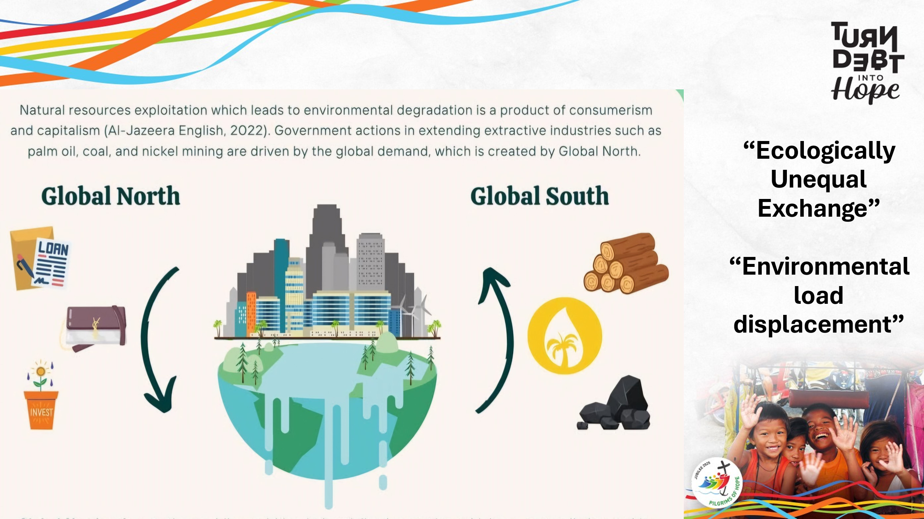
Now, this is not a social science lecture, so I am not going to give you a blast of the statistics and details. Here’s one depiction of the processes. slide here
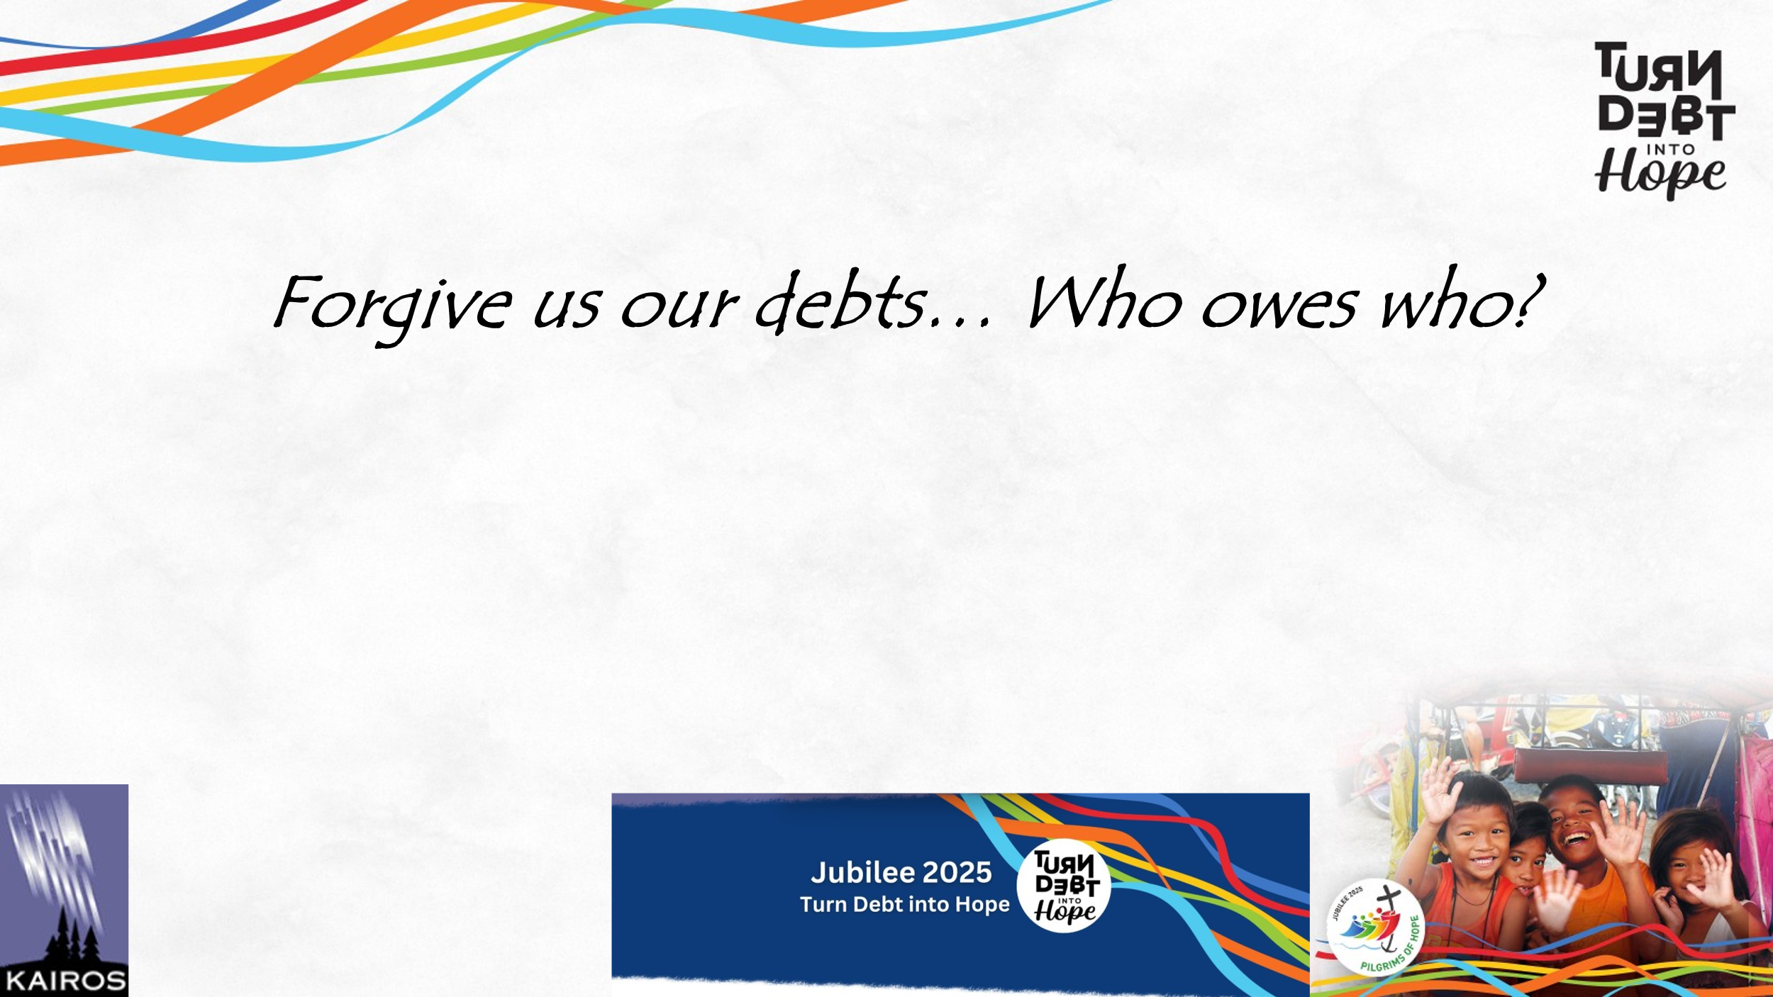
But let’s not go there. If you want, we can go for coffee, and discuss the data. slide here

The point is that we have a moral duty to scrutinize our responses to injustices of which we are a part.
Ecological debt is geographical, with historical roots in a system of colonialism, and worldviews of extractivism and domination. It is perpetuated now in contemporary NEO-colonial power relations– unfair economic trading practices and the power of financial institutions to set the rules and run the game to maintain the privileged positions of the already-wealthy nations like Canada.
Ecological debt is also intergenerational debt. The Future has loaned us in the present a stable ecology and loads of wealth and opportunity. But the future may struggle far more than the present does because of that loan, over which they had NO say.
Climate emissions are another form of debt. Industrialized countries have for almost two centuries used the atmosphere as a dumping ground for carbon. The atmosphere has been borrowed. Time to pay back the loan.

So What to do?
Become aware and repent! SEE the issue, JUDGE (or discern) the circumstances, ACT for change. See Judge Act. Change personal lifestyles and advocate for global systemic changes. WORK TOGETHER, for that IS the power of the People of God.

So we go back to Matthew, and we go back to the Lord's Prayer. We know we are sinners, we know that we trespass, we know that we have debts and we ask for "forgiveness of our debts as we forgive our debtors." And we go back to Leviticus and Deuteronomy for images of the practice of Jubilee. And we go forward, knowing that we follow Jesus who proclaimed liberation and the “acceptable time of the Lord”, that is, Jubilee for ALL GOD’s creatures human and the rest.

