**UNBOXING OUR FAITH - Sept1, 2024-corrected**

**(Sept 1 is start of Season of Creation)**

**Randy Haluza-DeLay**

(*Note: This is the “long form” items with ~~strikeout~~ were left out.)*

------------------

**“There is no box made by God nor by us,**

**but which the top cannot be blown off,**

**And the sides flattened out,**

**To make a Dance Floor on which to celebrate Life.”**

When I was asked to speak this weekend – given the summer series of “Unboxing our Faith” – this evocative quotation sprang instantly to tongue. Perhaps however, you might see it as a little facile. Afterall, we know the agony in the world. Is it fair or appropriate to dance amidst the misery of mental health, loneliness, depression?

How can we celebrate Life amidst the horrors of Gaza, Sudan, Yemen – the 120 conflicts going on in the world today! – grinding poverty, sexual assault as a weapon of war and oppression, dangerously accelerating climate change, and so much more that could be added to this list?

How can we dance amidst all this? Or as the psalmist wrote – in these contexts “How can we sing the Lord’s song?” In a land increasingly foreign to any of us, a land foreign even to God’s design for the community of shalom that is Creation?

Or, and by the way, Today marks the beginning of the season in the church calendar that is now called “The Season of Creation,” lasting until the Day of St Francis of Assisi on October 4th. It is an initiative of the Ecumenical Patriarch of the Orthodox Churches, the World Council of Churches, and the Pope of the Roman Catholic church.

But how can we blow off the box lid and celebrate life when fellow creatures of the world are dying? When we are part of perpetrating **Ecocide**?

For instance, there have been 70% loss of insects in some areas. Similar declines in birds - silencing the forest more than pesticides ever did. This is a world now where 96% of biomass of mammals are humans and our domesticated creatures - horses, cattle, sheep, hogs/pigs/pork/hams and so on; that means merely 4% of mammal biomass in the world are the few remaining elephants, ferrets, zebras, mice, rats, kangaroo and so on. As the Prophet Isaiah declared “Woe be unto us, who add house unto house and field unto field, until we live alone in the land” (Is 5:8). And humanity feels an alienation and loneliness and doesn’t notice the boiling of the planetary biodiversity crises…

~~To be honest, this tremendous reduction in wildness has its parallel with Unboxing our Faith. Unboxing is like opening the cage and letting the tranquilizer-drugged animal go wild again.~~

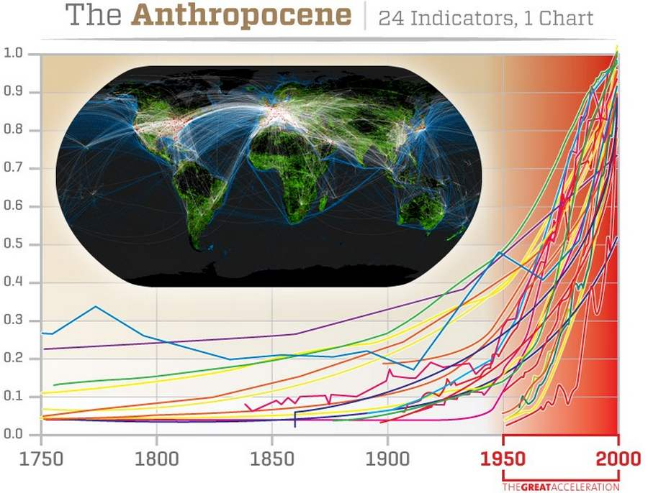Anyway, the dramatic decrease in biodiversity is part of what is meant by “the Anthropocene”. The term is a little contentious, but it is meant to convey that Humanity, the Anthropos, is a force of geological significance. Not only are we affecting the biological component of the planet, but the very earth itself – atmosphere, ocean acidification, the climate and weather, and more. Across MANY indicators, humanity is having a planetary effect (*Slide shows what is known as “the great acceleration” in terms of human impact on the planet*).[1]

The Anthropocene raises the questions: theologically, is homo Sapiens taking the place of god (sic), creating the world anew?

AMIDST ALL OF THIS, Celebrate We CAN, AND WE MUST! ~~It is necessary for our psychological health. It might also mean coming to terms with one’s own experiences and not judging them as “first world problems, not so bad as being in places ravaged by violence or hunger.” The Biblical account is that God wishes for all to flourish regardless of where in the world we are located – we are to Sing (and Dance) the Lord’s song and celebrate life.~~

This is how I am going to talk about “Unboxing our Faith” today.

First, To Celebrate - DESPITE these crises and agonies in the world and people’s lives

Second, because a Box is a Container, the task is not to let it “contain” in a limiting way.

And third, what that might mean. I suggest that we become “Holy Fools”

So let me start out by saying a few things about CELEBRATING IN THE FACE OF MISERY.

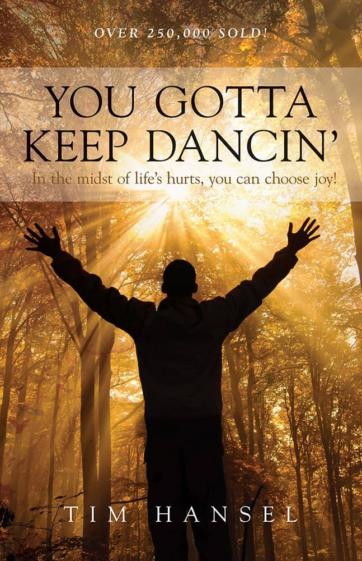**FIRST** – the quote comes from a book called “You Gotta Keep Dancing” by a fellow named Tim Hansel. Broke his back in a mountaineering accident. He has lived with a lifetime of sever and chronic pain and this is the attitude to which he aspires. His his witness, as someone trying to live what he preaches, allows me to feel OK sharing with you that quote and not thinking it facile.

~~In “Man’s Search for Meaning” detailing his experience of surviving a Nazi death camp, Victor Frankl, the German psychoanalyst observed much the same thing – that in the midst of life’s hurt and terror, the people who survive and thrive choose to do so, mostly by serving others.~~

**SECOND**, about 5 years ago, I had the opportunity to go with CPT – Christian, now Community “Peacemaker Teams” on a delegation to Northern Iraq. Kurdistan. This is the region where then Iraq president Saddam Hussein had engaged in a genocidal campaign called “The Anfal” against the people of the region. Against his “own” people some say, because they were Iraqis, but it really was an ethnic cleansing effort of his own Arab Iraqis against the Kurds in Iraq. To this day, Kurds face armed persecution in the 4 countries of Iran, Turkey, Syria and Iraq. But back in the 1980s, Hussein used chemical weapons, military incursions, torture and imprisonment.

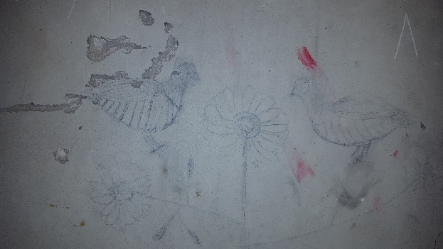How can we celebrate amidst the misery? When I was there, on the wall of one of the cells of the prison – Amna Suruka – we visited was this picture – of a bird found in the Kurdish mountains.

Even in prison, facing torture, knowing death was being visited on your people, maybe your family, and probably yourself here in this prison, one man reached out to produce a bit of beauty.

**THIRD**, I work for an international development agency that has partner organizations in Palestine and Gaza. Our partners tell us that amidst those horrible conditions – of which you are probably all aware – the people find ways to know joy. The alternative is despair. That way leads to death.

-------------------

I chose the Psalms that we read because of this. ~~There are three voices in these two Psalms:~~

1. An attempt to be faithful when things are going badly – how can we sing the Lord’s song in that foreign land… That is Psalm 137.
2. ~~Psalm 73 begins with the psalmist expressing Irritation at the success of the undeservigin.~~
3. ~~Eventually, the Psalmist switches, and expresses an attempt to continue to be faithful, DESPITE the evidence of their eyes that the undeserving are doing so well.~~

~~It is reading Psalms like these that point out that we are both/and – both the irritated and bitter along with the desires of faithfulness. In fact, the entire Bible is like that – no character really comes out as having it all perfectly handled. So, we need God, and as long as we keep going, we are OK in the eyes of God. Thank the Lord! (Can I have an “amen”?) No need to give up, just keep opening the container that is “faith” and let the Holy Spirit of forgiveness out!~~

– Psalm 137 expresses an attempt to be faithful when things are going badly – how can we sing the Lord’s song in that foreign land… This is the Psalm that begins “By the Rivers of Babylon we sat down and wept, when we remembered Zion. But I didn’t want to include that first verse because it is so familiar, and at least some of the time Familiarity loses something that is really necessary to hearing Scripture well. In other words, Familiarity can be a Box, it can “contain” us, as well as provide support and stability.

**So, UNBOXING OUR FAITH requires going along with being open to surprise.** Frankly, this is part of being real and being real in “real life.” Look at Psalm 73.

~~– our Psalm 73 is a two-parter. The First Part that we read shows the Psalmist in longterm resistance to indulgence, self-centred interest, accumulation of wealth, and so on, BUT IT STILL EXPRESSES ENVY.~~

~~Eventually, the Psalmist begins to conclude – faithfulness is foolishness, because exploitation DOES work well. But then there is a turn.~~

~~The writer seems to gain a fresh awareness AS GOD SEES things. – arrogance will not last (As Mitri Raheb, the Palestinian theological says about that region of the world: Empires come and go (Roman, Byzantine, Egyptian, Persian and Babylonian before them, Crusader Europeans, Various Islamic caliphates, the Ottomans and the British – and now the Israeli-American empire? BUT THE MEEK OF THE LAND REMAIN. That sounds like foolishness, but it is a part of Palestinian resistance. )~~

~~In an essay about this Psalm, Walter Brueggemann notes that the writer kept going the way of the first part until in verse 17 – the “turn” happens when they “* enter into the sanctuary of the Lord” and then began to perceive more like god does, and then slowly turns back toward the good path in their own life. It was like the psalmist had put themselves into a box and then coming close to God opened up that box and they began to live well again.~~

~~Whatever else, the later part of the psalm also indicates that while the wealthy, successful, and elites seem to be doing well – it is probably for their own, individual benefit, but God’s way is to bring EVERYONE along. Like the saying from anti-oppressive movements:” “How can we be free if all of us aren’t free.”~~

**~~Back to Surprise as part of the UNBOXING of our faith.~~**

Many years ago I read a book on liberation theologian by the theologian and civil rights activist Robert MacAfee Brown. In the context of ways that the Bible and Christian faith also facilitates oppression, such as baptising segregation and racism, he said the antidote was that EVERY TWO YEARS WE SHOULD ENDEAVOUR TO FORGET EVERYTHING WE “**KNOW**” ABOUT Jesus.

That is also among the reasons that I chose the passage from Corinthians – we are saved by faith. In the Greek world “wisdom” was often equated with “knowledge” – as if you will INTELLECTUALLY know the Truth and REASON will set you free. Since I was trained as an academic – a social scientist, a researcher – the excessive valorization of Intellect, Reason, and Rationality is a risk.

Back to the Season of Creation for a moment – we know pretty serious global degradation is occurring (and I would say based on the knowledge base in my field of study – it is worse than you realize). **But since we know this, so why don’t we humans turn back, repent, become converted to God’s good way? Obviously there are BLOCKAGES.**

For example, in the context of the creation-degradation that is the Anthropocene, I have heard it said that even though among the root causes we can identify the wealth accumulation, wealth concentration, and continued wealth extraction that is our current global economic system – It is easier to imagine the end of the world than to imagine the end of Capitalism.

**Unboxing our faith requires Imagination. It is a part of getting rid of those Blockages – to imagine an UNBLOCKED UNBOXING.**

If “Unboxing our faith” implies that there is a box, and probably that we or our faith is in that box, then UNBOXING FAITH means finding a way to step out of the Container – a container which **even if it is NOT of our own making**, might involve us ourselves staying inside it.

~~Maybe you know the story from that good pagan, Plato – what is known as “Plato’s allegory of the Cave.”~~

*~~In the allegory, Plato describes people who have spent their lives chained in a cave facing a blank wall. They watch shadows projected onto the wall by objects passing in front of a fire behind them, and they give names to these shadows. The shadows are the prisoners' reality but not accurate representations of the real world. The shadows represent the fragment of reality we can perceive… (description adapted from Wikipedia, )~~*

~~Now, I am going to stop with Plato’s explanation there. For Plato, the solution to seeing the reality is via REASON. I have already alluded to the correction that Scripture gives me – that as a highly educated person, trained in the social sciences and working in the university sector, I think I CAN figure all things out through reason. But then the foolishness of the cross, the general foolishness of Jesus call me out.~~

~~So there may be many ways of trying to figure out what is shadow and what is reality. The point I want to make, since it IS an ALLEGORY, is that the cave dwellers – that is the PRISONERS chained to the wall could presumably TURN AROUND and see that which is casting the shadows. UNBOX THEMSELVES! Leave the Cave.~~

~~Is that reTHINKING things? Or is that something more transformative – that probably involves all sorts of mental, emotional and spiritual forces, and most of all – the Holy Spirit.~~

**UNBOXING our faith means UNBLOCKING.**

That means trying to figure out what BLOCKAGES I, or You, or even WE have. We have them at the individual levels – I for one know have terrible narratives about myself, especially given the past several years of mental health and employment struggles. There are collective blockages too – what keeps Israelis from making Peace in the Land? What blocks Muslims in the region or Americans in their imagining of a different future in Israel-Palestine? What keeps the countries of the world from doing what is necessary to confront the extremely well-evidence climate or biodiversity crises? And so on. Pope Francis wrote that what is needed is “ECOLOGICAL CONVERSION” which recognizes the *spiritual*  fight and not only the economic or social or political.

Or, as I began to prepare this sermon, ~~like I often do, I posted to a few social media sites asking what people thought of the topic of “Unboxing our Faith”. Doing that is a good practice, because it allows the many contacts I have who are not Christians (or my type of Christian) to weigh in, which means the faith is sort of taken out of the box anyway and let wild into the world.~~

*~~A couple people pointed out that Mennonites should be less pugilistic, meaning “why are Mennonites in the Boxing Ring? Just stop punching!”~~*

One person reminded me of the famous passage in Revelations (Revelation 3:20) where Jesus is standing at the door and knocking. Presumably he is knocking at a person’s heart. The assumption is usually that Jesus is knocking to be let in to our heart.

MAYBE, he is knocking because he wants to let us out of the container we have allowed ourselves to be stuck in. Be free! Be Wild!

**What is The opposite of Faith? I would say the opposite of faith is MAINTAINING CONTROL.**

For the rest of this message I want to talk about “Unboxing faith” in this context – how Jesus asks us to step outside and join Him. And for better or worse, I am going to suggest that UNBOXING, which I have been saying means “letting go of control”, means becoming a Holy Fool.

So here are the lyrics from a song by Michael Card <https://www.youtube.com/watch?v=dlZz50za7Q4>

***GOD’S OWN FOOL – Michael Card (Album “Scandalon”)***

Seems I've imagined Him all of my life

As the wisest of all of mankind

But if God's Holy wisdom is foolish to men

He must have seemed out of His mind.

For even His family said He was mad

And the priests said a demon's to blame

But God in the form of this angry young man

Could not have seemed perfectly sane.

When we in our foolishness thought we were wise

He played the fool and He opened our eyes

When we in our weakness believed we were strong

He became helpless to show we were wrong.

And so we follow God's own fool

For only the foolish can tell-

Believe the unbelievable

And come be a fool as well.

***OK – so how do we become Holy fools?***

Let me give you a few examples. BUT, as a foundation, let's remember that the gospel itself is foolishness. And here I don't mean just the foolishness of Jesus - the divine - allowing himself to be killed- ~~which by the way, is~~ **~~anathema~~** ~~to Muslims who hold Jesus in such a high perspective that they insist God could not let his most holy human be killed like that.~~

The gospel is foolishness in so many other ways - love your neighbors, okay, but love your enemy? The first will be last, the last will be first? Somebody who works 1 hour may get paid the same amount as somebody who works the whole dang day. It's easier to go through the eye of a needle than for a rich man to get into heaven. There's all kinds of craziness and foolishness in the gospel. And so Paul says it is a scandal to the Jews and foolishness to the Greeks.

**As in 1 Corinthians, “If any among you seem to be wise in this world, instead become a fool, so that you might become truly wise…”**

**With that, there are two examples I want to sketch.**

First a historical one - Francis of Assisi.

SECOND, how we “defang the dragon”?

St FRANCIS of Assisi:

DO YOU KNOW HIS STORY? (because Season of Creation ends on Oct 4-a day of honour for Francis). I would say that he is the most Anabaptist Catholic saint out there.

* Son of a wealthy merchant in 12th century Italy
* Went off soldiering
* Came back a damaged person
* Convalescing, had visions of Christ, threw all his fine, rich clothes out the window and marched through the town square naked and out to a broken-down church to “rebuild the church.”

***IMAGINE one of your young adults having such a radical conversion about “fast fashion” and faith, pitching the clothes, and walking buck naked down to the local Value Village. How far a walk would that be? Would they be naked on TTC instead? FOOLS indeed? But HOLY fools??***

* ~~People collected around Francis.~~
* ~~There are numerous Franciscan orders, and even Secular Franciscans (Third order – regular people taking vows), involved in peace movements, Indigenous solidarity and more.~~
* ~~From the beginning, Francis and those around him had a (radical at that time) focus on “the poor”, “nature” and “a radical vision of Christ.” Even “peace” – peace with nature, and Francis actually travelled to see the Sultan of Egypt (this was during the time of the Crusades (4~~~~th~~~~?) and try to broker an end to the Cht-Muslim wars (crusades). PEACEMAKER!~~

**~~SECOND – DEFANGING THE DRAGON.~~**

~~OK, this mixes metaphors a bit but I want to tell you about it.~~

~~I currently work for an international development agency that is an arm of the Catholic Church in Canada. When I tell people I left a secure university position and now work at a Catholic social justice, there are two consistent comments. The first is “have you lost your mind?” The second is “Catholic~~ *~~and~~* ~~social justice? That's an oxymoron!” OK, NOW we are going to talk, because there is a RICH tradition of Catholic social justice teaching…~~

~~Last week we held a summer camp session on Christian Student Leadership. We ran workshops for those 40 teens focused on global justice issues. One workshop started with a particular reading of Revelations… You might recall the imagery, the 7-headed dragon, ready to devour, blah, blah, even devour the Woman with Child. Wait – what? The woman with child??? Ok, are you thinking about the Birth of Christ now? Mother and Child?~~

~~The workshop was to try to get the participants to think about the social forces in the world that are the demonic ones that keep them and other humans from flourishing as the Creator intended. OR, to get more specific – what are the heads of the dragon that lead toward the earth’s ecological degradation?~~

* ~~Greed?~~
  + ~~Sure, but do “sins of the heart” that are often seen individualistically really become demonic social, political, economic systems? Sure, but this requires “conversion” which is hard to bring into social analysis and fixing global problems.~~
* ~~Capitalism?~~
* ~~Wealth accumulation stripping countries of the Global South by countries of the Global North like Canada?~~
* ~~Colonialism that was once militarily enforced and now is a global economic order?~~
* ~~I hope you can add to this very short list.~~

If the gospel is foolishness because of the cross of Christ, it is also foolishness because of Christ’s preaching about the way we should live. For many people, these sorts of social forces are inevitable and normal, but **they may not be good** Christian practice. As the world changes, so too do our specific responses to war or degradation or use of fossil fuels to heat the planet, and so on.

To talk about changing these things which are SO ENGRAINED in our imagination, requires conversion and a willingness to appear the fool. I come from Alberta; BURNING of fossil fuels are about 75% of the human-causes of the changing climate but imagine talking to Albertans or that government about needing to eliminate fossil fuels?

A caveat however – one has to be prepared to bear the cost… Later in that song I read you, Michael Card includes this verse also

So come lose your life for a carpenter's son

For a madman who died for a dream

And you'll have the faith His first followers had

And you'll feel the weight of the beam.

Even a Holy Fool will have to lift their cross and bear it. ~~You might have to leave your job or your province. Your “foolishness” might actually bring a sword into families (families split over Trump; brother against brother in the American civil war).~~

AND THAT IS WHY WE NEED COMMUNITY!!!! That is why we need support, to gather together, to keep each other going…. Ecological degradation can't be fixed by individual acts of simpler living. A collective act can be a witness - but this is part of why I said Community is useful, or necessary. We are not in this foolishness alone!

Let me conclude this example of being Holy Fools by stripping in front of you….

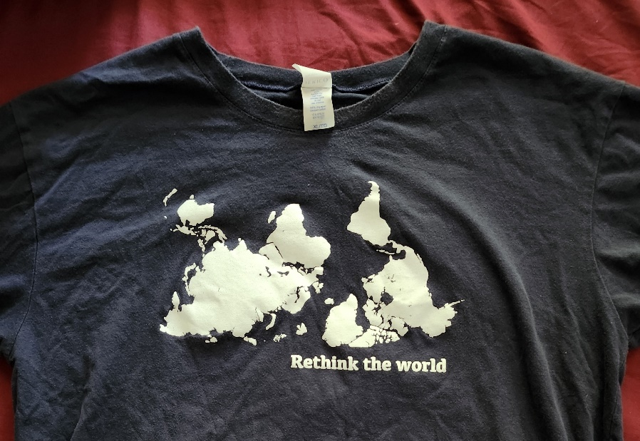A big part of my work with Development & Peace are education programmes. A primary goal is the theme expressed on this shirt. I ask “What do you see”. They see a map. Inevitably someone says “but it’s *upside-down*” and that gets us into a discussion about why they think that? The point is to **RETHINK THE WORLD,** that is, to consider why we think something is “normal”. In other words, to **DE-NORMALIZE** things.

Why are things “this way” and not like what we imagine the Kingdom of God? How do we get out of boxes that “contain” us too much to let the Spirit of God run wild in our lives and our faith, and so on.

**CONCLUSION:**

So in conclusion----

Jesus is standing at the door of your heart knocking will you come out of the box and join Jesus? Will you blow the lid off and flatten down the walls? And Celebrate Life?

**Unboxing the Faith** means blowing off the containments and dancing wildly with Jesus, denormalizing anything that gets in the way of God’s Shalom community and Peace-making and full flourishing of all people and all creation here on earth as God intended. It does that difficult work together in community in a way that helps every being in the community of creation to move forward in participation in love with the divine. We are fools – and that is a good thing!

~~And if you need something more specific, let me leave you with three points that are in contradiction to the sensible normality of our culture.~~

1. ~~Love yourself. Your Creator loves you – as you are and as God is calling you to be. But for now, you are enough, you are forgiven, and you are loved into becoming who you will become. That attitude is foolish in the eyes of a consumer marketing system that needs to sell us stuff to overcome our lack of those things.~~
2. ~~Oppose violence, in all its forms. War is only the tip of that violence. The earth and its inhabitants cry out for peace. Make peace in your life, in our political systems and in our workplaces or the companies for which we work. You will feel foolish. That’s OK.~~
3. ~~Rethink the world – care for the earth; listen to the cry of the earth and the cry of the poor. Ask why there are poor. Oppose everything that degrades the earth and the poor, even if it is our sacred cows of economics, fossil fuel burning, air shows that support militarism, ***. Look the powerful in the eyes and giggle.~~
4. ~~Have fun being foolish!~~

~~(and yes, I know I said 3 things, and then mentioned 4. So foolish, eh?)~~

Or, selections from a poem by Wendell Berry:

*Friends!*

*Every day do something that won't compute. Love the Lord. Love the world. Work for nothing.*

*Take all that you have and be poor.*

*Love someone who does not deserve it.*

*Expect the end of the world. Laugh. Laughter is immeasurable.*

*Be joyful though you have considered all the facts. Practice resurrection."*

*These are foolish words, but they sound pretty gospel/Jesus-like?*

*Speaking of “Holy Fools” that, by the way, is culled from the Poem – “The Mad Farmer’s Liberation Front.”[2]*

And now that I have said so much to you – let me leave you with this picture – wisdom from a beer can! Despite all this talk about “Unboxing” the reality is:

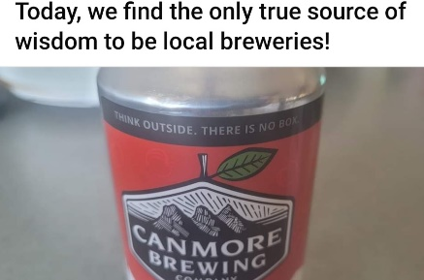

**“Think outside. THERE IS NO BOX.”**

So let us end as we began -

**“There is no box made by God nor by us,**

**but which the top cannot be blown off,**

**And the sides flattened out,**

**To make a Dance Floor on which to celebrate Life.”**

1. <https://journals.sagepub.com/doi/abs/10.1177/2053019614564785?journalCode=anra> ~~Indicators of human impact increasing. These include:~~

   ~~Growing human population, Energy Use, Water use, Land use, Climate-related emissions, Fertilizer consumption, Surface temperature of atmosphere, Stratospheric ozone (increased, then stabilized, but not a lot of decline – takes a long time – BUT AT LEAST WE STOPPED INCREASE!), Marine fish capture (meaning, decline in fish populations – massive increase, then decrease (because fish stocks are low now), Ocean acidification, Tropical forest loss, species extinction (but also massive biodiversity losses even among nonendangered species).~~
2. Full poem at <https://bookpeopleblog.com/2011/04/05/poem-of-the-day-manifesto-the-mad-farmer-liberation-front/>